Assignment: Answer the following questions from chapter 2 of textbook

Name: Period: Date:

Multiple Choice questions from page 41 of textbook (Fill box with answer)

1. C.

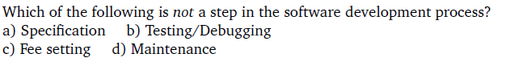

2. A.

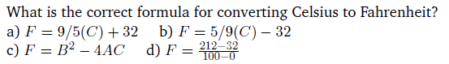

3. C.

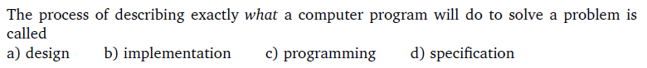

4. C.



5. D.



6. B.

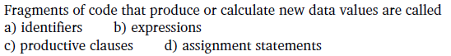

7. B.



8. A.

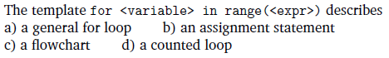

9. A.

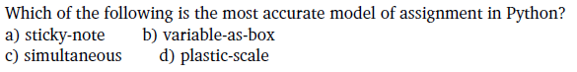

10. D.



11. Discussion question (Write output)

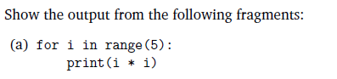

0,1,4,9,16



3 1 4 1 5



Hello

Hello

Hello

Hello



0 1

1 2

2 4

3 8

4 16

Programming Exercises

12. (Submit the modified program file avg2.py with this assignment)



13. (Submit the modified program file convert.py with this assignment)



14. (Submit the modified program file futval.py with this assignment)

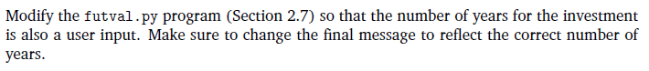

15. (Write the program factorial.py using the flow chart below, Hint: use a while loop)

